John Michael Go
Career Entry Level Java Programming
Date: Jan. 22, 2013

DAY 8

Program Name: Array4

Objective: Sample program for string array.

Algorithm:

1. Program outputs the string elements of an array.

Flowchart:

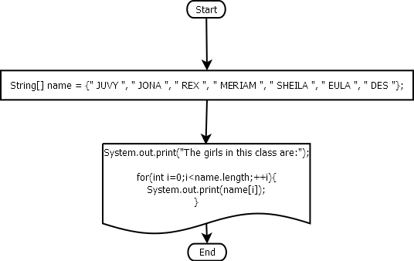

Pseudocode:

public class Array4 {

public static void main(String[] args) {

String[] name = {" JUVY ", " JONA ", " REX ", " MERIAM ", " SHEILA ", " EULA ", " DES "};

System.out.print("The girls in this class are:");

for(int i=0;i<name.length;++i){
System.out.print(name[i]);
}
System.out.println();
}

}

Screenshots:

